SAVING ANDREW
By Denise Lawungkurr Goodfellow

Andrew is one of my Aboriginal relatives - I call him “nephew”. Now in his thirties, he is a Larrakia, and one of the traditional owners of the land Darwin sits on.

When Andrew was only ten his father died, followed three years later by his mother. Both events must have shattered the little boy. His sister, Stephanie and her husband, Reverend Nganjmirra did their best to give him a decent upbringing. However, they were fighting a culture of drinking that existed among their close relatives. For example Andrew’s big brother was an alcoholic who stole money from his grandmother, and treated his wife and children appallingly. Andrew began to drink with his brother from an early age.

Andrew wasn’t in the best of health, having been born with a heart murmur. And drinking caused other problems. Late one night I received a call from a doctor in emergency at the request of several relatives who’d brought Andrew to the hospital. While drunk he had sat on a broken flagon and carved a lump out of his backside the size of a large fist. He was bleeding to death, but because he was thrashing around and incoherent, the doctors couldn’t treat him. I calmed him down so the doctors could do their work.

I remember well his big brother’s funeral. Some silly siren of a missionary with long golden locks screaming “Hallelujah, he is saved”, because big brother had found God on his deathbed. Too bad about those he’d injured as he’d careered, self-centred, through life. As his women relatives looked on stony-faced the coffin was carried through a guard of honour made up of men from his football team. Each, from the young to the old, had the swollen belly, bleary eyes and haggard face of a hard drinker. What chance did young Andrew stand!

But despite this sordid history, Andrew was a gentle, caring giant of a man. When my son Rowan was bullied on the way to school, Andrew offered to escort him there and back. He wasn’t going to attack the bullies, but just point out the error of their ways. After her husband’s death Stephanie became too ill to cook for herself and Andrew took over.

Andrew’s grandfather, a Larrakia man, passed down much knowledge to the little boy, knowledge that it seems most others don’t have. Yet Andrew and Stephanie’s family were largely left out of the land claims over Darwin. Andrew said of other claimants at one meeting that they “didn’t know anything”. But they were being heard and he wasn’t and so he left. And with no one to pass that knowledge to, it seemed it would die with him.

Did this lack of inclusion play a part in the escalation of his drinking? Yet another type of exclusion may have also played a part. Stephanie and I wanted to work together on a series of videos and papers documenting our family and a little tourism project we started in Arnhem Land. This was to be part of my PhD, and, hopefully a degree for Stephanie in which we could involve all the family. Andrew suddenly had some direction and he was so excited. Enthusiastically he offered to help his sister and include his knowledge and experience as well.

Guided by Stephanie I wrote the ethics application. In the covering letter I wrote that the committee needed to contact Stephanie so that she and other family members could voice their opinions of the project. This was the Aboriginal way of doing things. But the ethics application was refused - I “hadn’t followed the Australian guidelines for showing respect to Aboriginal people”. Stephanie accepted the proclamation in quiet despair, but Andrew was furious. Once again they were being denied a voice.

Not long after this, I noticed that Andrew’s drinking increased. There were now continual drinking parties, and while no violence occurred, the house was left absolutely squalid. The women gave up on trying to clean the place knowing it would be just as bad the next day. Stephanie and Dianne, Andrew’s wife, asked me to talk to him.
I had raised the subject of alcohol with Andrew on several occasions, knowing my words were falling on deaf ears. But there was one person that, I was sure, would reach him– my son and Andrew’s cousin, Rowan..

Last week Rowan came to visit. Now Rowan’s a big, tough bloke – and into martial arts. But he has another side. His girlfriend Nora told me that what attracted her to Rowan was seeing the kind, gentle and patient way he treated his sister, Amber. And then there was his treatment of Stephanie. Now paralysed, she needs help in virtually everything she does. Rowan looked after her as gently as he would his own child. And Nora followed suit. The photo shows them helping Stephanie into the car.
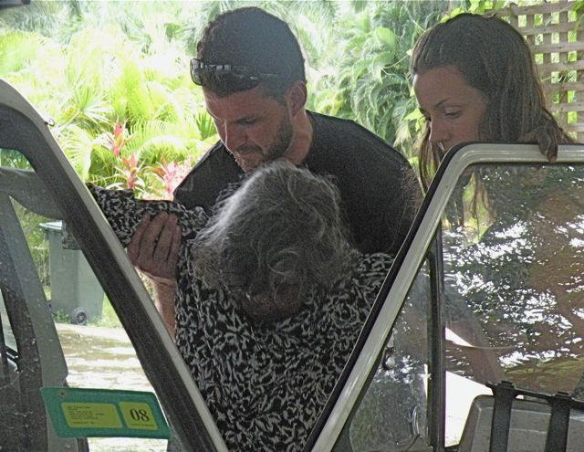
Rowan and Nora took Andrew out fishing across the harbour. Previously Andrew had said he wanted to pass on his Larrakia knowledge to Rowan, and now he began to do just that, telling him of the dreaming and ceremonial sites they passed. Then they began to talk of Andrew’s drinking. In his gentle but “take no rubbish” way, Rowan told him that we wanted him “around for the long haul”. But no one except me really believed Rowan could make a difference.

Yet even I could scarcely believe what happened next. The morning after the fishing trip Andrew caught a bus to the rehab centre to make arrangements to go into residential care. He’s put me down as next of kin - I’m to be present at every meeting staff have with him. Rowan is going to return later this year, hire a 4WD, and drive Andrew around the Darwin area, fishing and talking about knowledge.

We expect Andrew will slide a few times, and in the end he may fail, or the physical damage already done may be just too great and he’ll die. But this is the first positive sign we’ve ever had. Andrew now has a chance.

